Detailed Description:
Computer interfaces that use "natural" interaction have been termed, appropriately, natural user interfaces, or NUI. The implication is not so much that the interface itself is natural, but that the interface is very easy to learn, and in that sense natural. Natural user interfaces are a very active research topic, and a wide variety of prototypes have been demonstrated.
In this project, we’d like to build a middleware solution for the Smart Connected Communities. The goal is to provide a distributed platform that will offer intent recognition (e.g., light switches on, more than 2 people in the room, sound of human or cat, any hand gesture that maps to a certain control of a device, etc.) services. Applications running on this platform can then make use of these user intents using a Pub/Sub model to perform various user-specific tasks such as increasing the air from the HVAC, lowering the temperature of the refrigerator, etc.

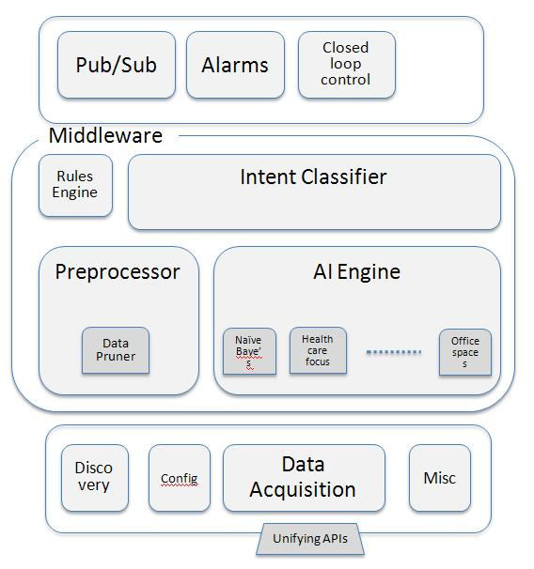
The components of this middleware can be split into two parts, i.e., the southbound interfaces and the northbound interfaces. The southbound interfaces will communicate with the sensors and perform the following tasks:
Figure 1 Middleware Architecture
1) Device Discovery
2) Device configuration/capability recognition
3) Data Acquisition
4) Misc.

The northbound interfaces will perform the task of Pub-Sub interface for intents. See Figure 1 for the detailed architecture.

Between these two sets of interfaces we will have algorithms that will correlate and process sensor data and perform intent recognition. This will include image processing, time series analysis, etc.

Students should provide one or two types of published data (light switches, people in the room, sound recognition, etc.) with subscription specification of intents (on/off, more than 2 ppl in the room, cat sound in the room, etc.).

Specific goals/deliverables for the project are:
- Use a Kinect module as the sensor (to be supplied by Cisco).
- Define southbound APIs (Will be graded based on extensibility to different types of sensors).
- Implement southbound APIs (Will be graded on scalability for volume of sensors).
- Implement template code that will be used as glue logic to convert raw sensor data to the format expected by the Data Acquisition API (Will be graded based on amount of changes a user needs to make per device).
- Implement code to recognize 4 gestures (to be negotiated with TA) and do a one-to-one intent mapping (rudimentary intent engine for completeness).
- Implement source to create a Pub-Sub of the intents. Preferably XMPP based implementation. Use open source XMPP libraries as required (for completeness).

What is not expected of you:
- Implementing AI algorithms – Any open source Naïve Bayes classifier will do (we will supply one).
- North bound interfaces – Again any open source Pub/Sub mechanism will do ( will supply one).
- As mentioned above these components are for completeness of the project and you are not going to be graded on these components. The focus of this project is Extensible/Flexible design of the southbound APIs. Show your flair for software design.

Deliverables for this project:
- Code – You will have to relinquish sole rights to this code (aka, open source it ☺).
- Reasonable documentation – We are engineers so we prefer documentation that shows up on vim. Even better if you comment your code.
Resources:
http://www.linuxjournal.com/content/kinect-linux?page=0,1
OpenKinect: http://www.openkinect.org
OpenNI: http://www.openni.org
Please refer to http://www.linuxjournal.com/content/kinect-linux?page=0,1 for the difference between the two
Kinect Teardown: http://www.technologyreview.com/video/?vid=644

